Reporting Engine for QHSE KPI Submission & Consolidation

1. Objective
To enable standardized, scalable, and auditable QHSE KPI data collection from all PIF DevCos, with centralized calculation and consolidation using PIF-defined formulas, fully integrated within the Salama platform.
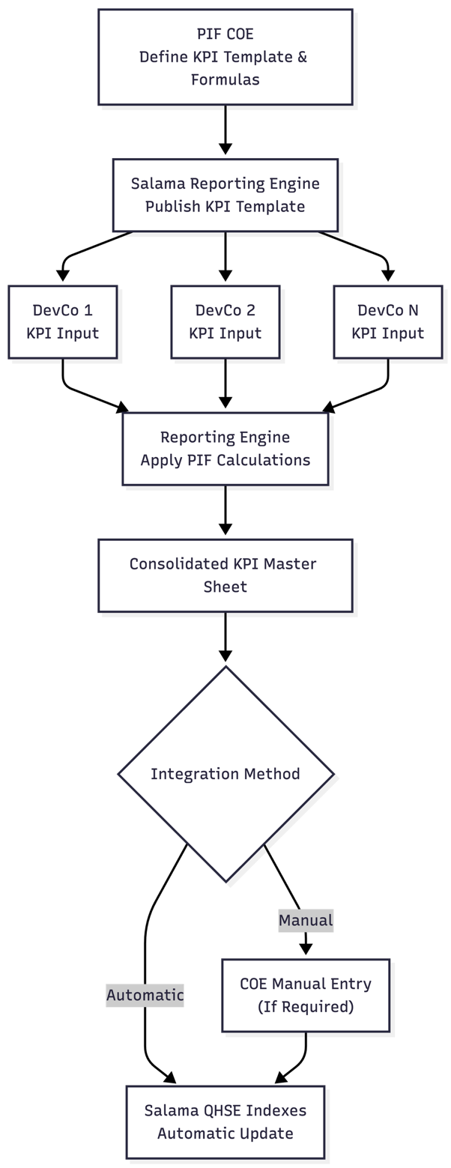

2. Standardized KPI Template Management
- PIF (via COE) will define and own standardized QHSE KPI templates for DevCo submissions.
- Templates can be:
  - Created directly within the Salama platform using the Reporting Engine’s native spreadsheet interface, or
  - Uploaded as pre-defined templates and converted into Salama-managed forms.
- Templates will support:
  - Structured fields
  - Validation rules
  - Version control
  - Audit traceability

3. DevCo KPI Submission Process
- Each DevCo will securely log into the Salama platform on a monthly basis.
- DevCos will complete the PIF-issued QHSE KPI template directly within Salama.
- Upon submission:
  - The completed template is automatically saved in the Salama Reports module.
  - Submissions are time-stamped, locked, and auditable.
- The system is designed to support a large number of DevCos and projects without performance degradation.

4. KPI Calculation & Consolidation Logic
- Salama’s Reporting Engine will ingest all submitted DevCo templates.
- PIF-owned internal KPI calculation formulas (for both Quality and HSE) will be:
  - Configured centrally within the Reporting Engine
  - Applied automatically to each DevCo submission
- The engine will:
  - Execute calculations per DevCo
  - Normalize results where required
  - Generate a consolidated master KPI sheet covering all DevCos
Note: All calculation logic remains configurable and fully controlled by PIF.

5. Output & Integration with Salama QHSE Indexes
- The consolidated KPI outputs can be:
  - Automatically integrated into the Salama QHSE Indexes module, or
  - Reviewed and manually entered by the PIF COE team where required.
- This provides flexibility for:
  - Governance review
  - Exception handling
  - Transitional or phased automation

6. Reporting Engine Capabilities
- Salama will provide a native, platform-owned spreadsheet interface, eliminating reliance on external tools.
- Key capabilities include:
  - Template-based data collection
  - Centralized formula execution
  - Multi-entity consolidation
  - Secure role-based access
  - Full audit and submission history
- All reporting, calculation, and consolidation workflows are executed entirely within the Salama ecosystem.

7. Value to PIF
- Single source of truth for QHSE KPI reporting
- Standardized submissions across all DevCos
- Reduced manual effort and error risk
- Transparent, auditable KPI calculations
- Scalable foundation for future automation and analytics

